Seller and Inventory Management System.
Project Title: Seller and Inventory Management System

Project Title : Seller and Inventory Management Database System
Student Name : Yoga Moorthy S
Register Number : C4S38025
Department : B.Sc Artificial Intelligence
Course : Artificial intelligence (AI)
Academic Year : 2024 – 2027

1. Create Database
CREATE DATABASE SellerInventoryDB;

USE SellerInventoryDB;

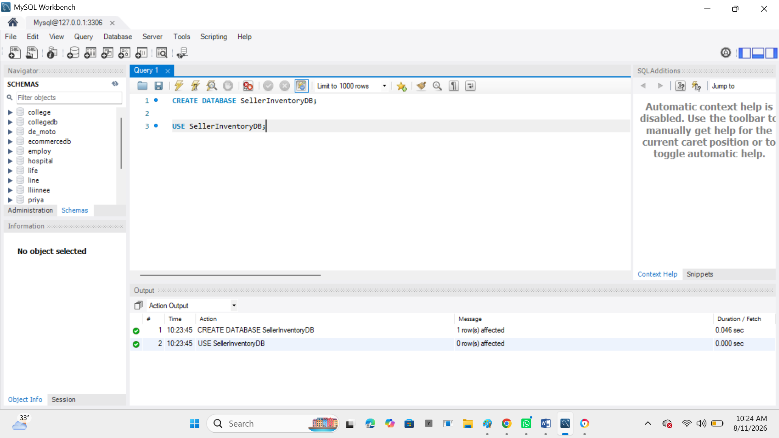

2. Create Seller Table
CREATE TABLE Seller (
seller_id INT PRIMARY KEY AUTO_INCREMENT,
seller_name VARCHAR(100) NOT NULL,
email VARCHAR(100),
phone VARCHAR(15)
);

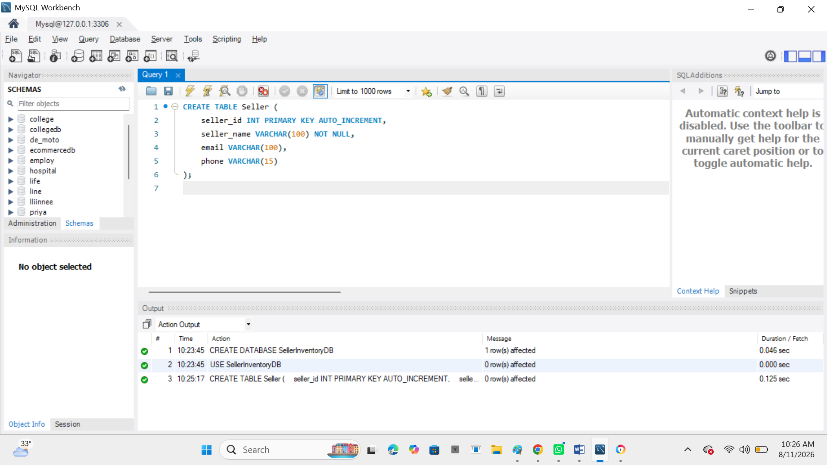

3. Create Product Table
CREATE TABLE Product (
product_id INT PRIMARY KEY AUTO_INCREMENT,
product_name VARCHAR(100) NOT NULL,
category VARCHAR(50),
price DECIMAL(10,2)
);

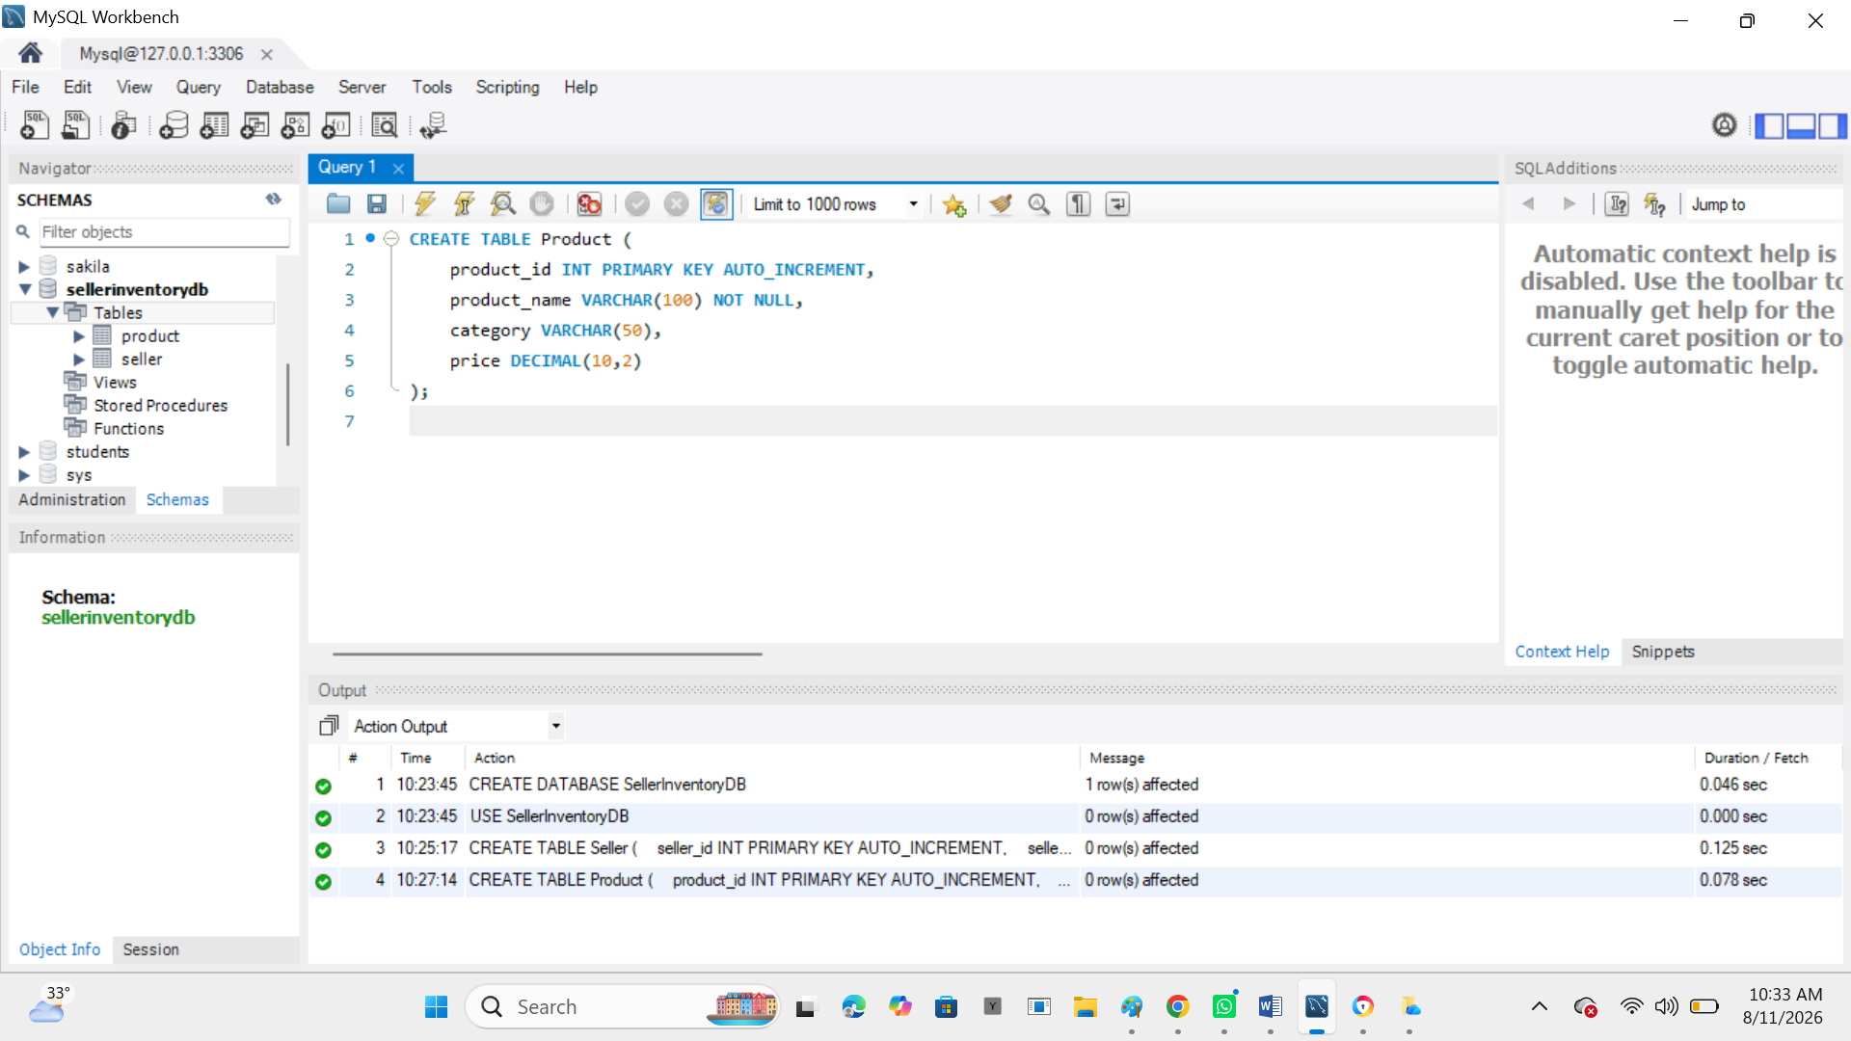

4. Create Inventory Table
The Inventory table connects the Seller and Product tables.
CREATE TABLE Inventory (
inventory_id INT PRIMARY KEY AUTO_INCREMENT,
seller_id INT,
product_id INT,
quantity INT NOT NULL,
status VARCHAR(20),

FOREIGN KEY (seller_id) REFERENCES Seller(seller_id),
FOREIGN KEY (product_id) REFERENCES Product(product_id)
);
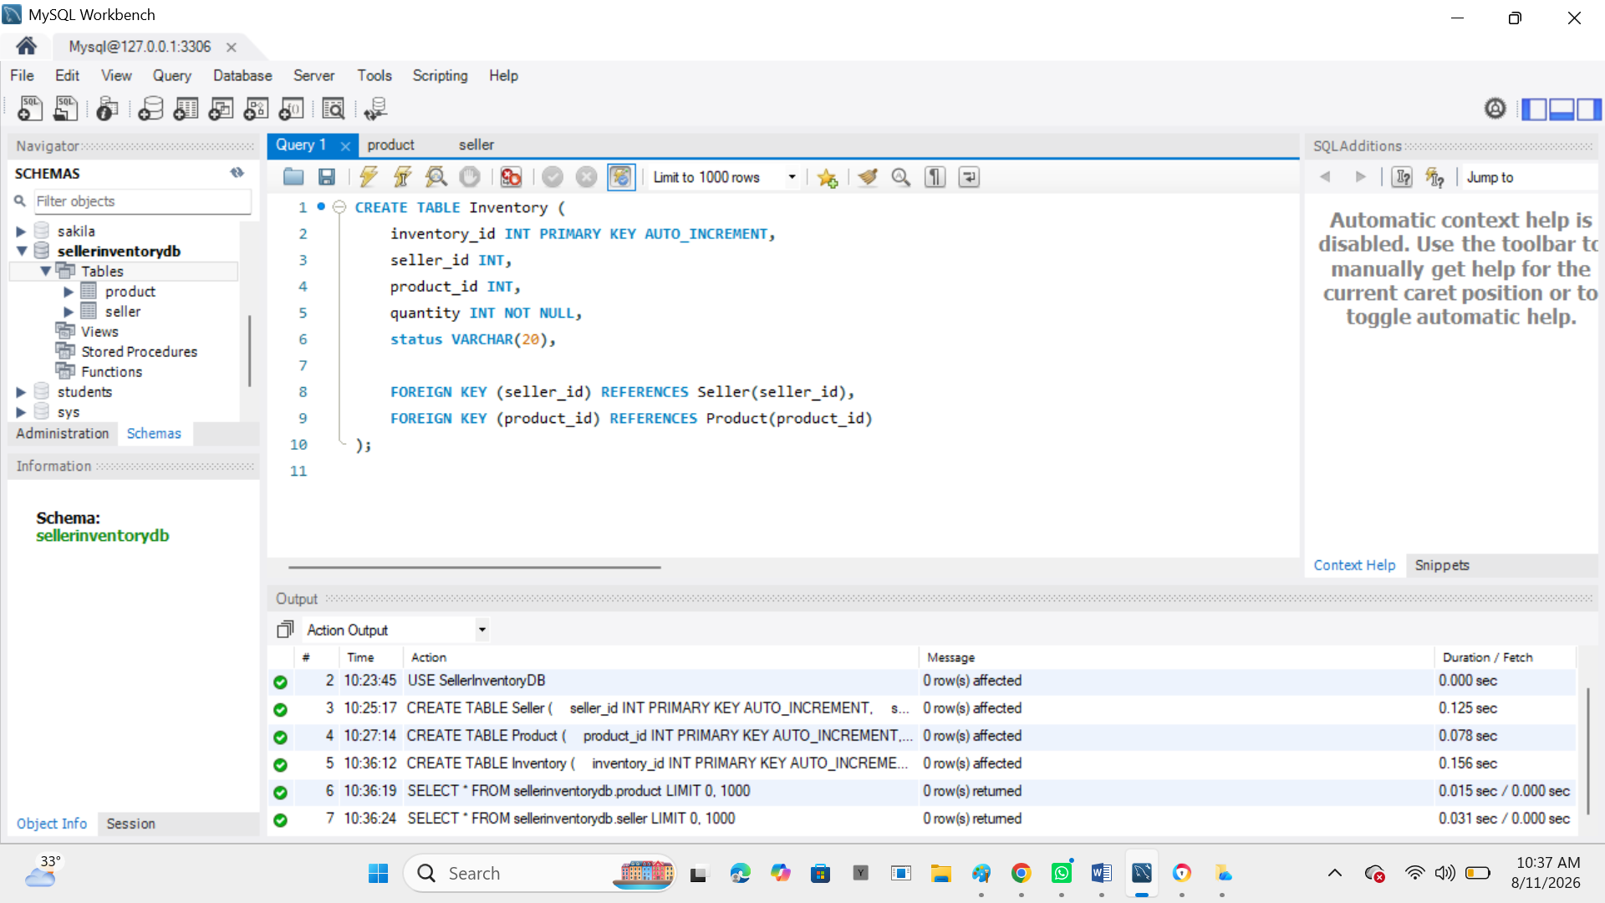

5. Insert Seller Details
INSERT INTO Seller (seller_name, email, phone)
VALUES
('Ravi Stores', 'ravi@gmail.com', '9876543210'),
('Priya Mart', 'priya@gmail.com', '9876543211'),
('Kumar Electronics', 'kumar@gmail.com', '9876543212');
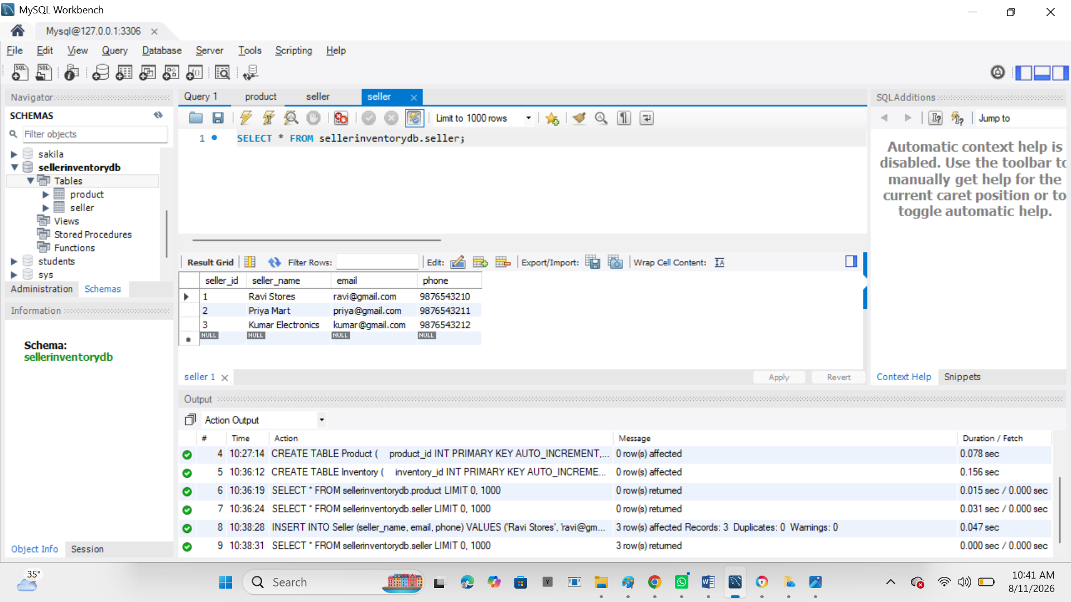

6. Insert Product Details
INSERT INTO Product (product_name, category, price)
VALUES
('Laptop', 'Electronics', 55000),
('Mobile Phone', 'Electronics', 25000),
('Headphones', 'Accessories', 1500),
('Keyboard', 'Accessories', 800);

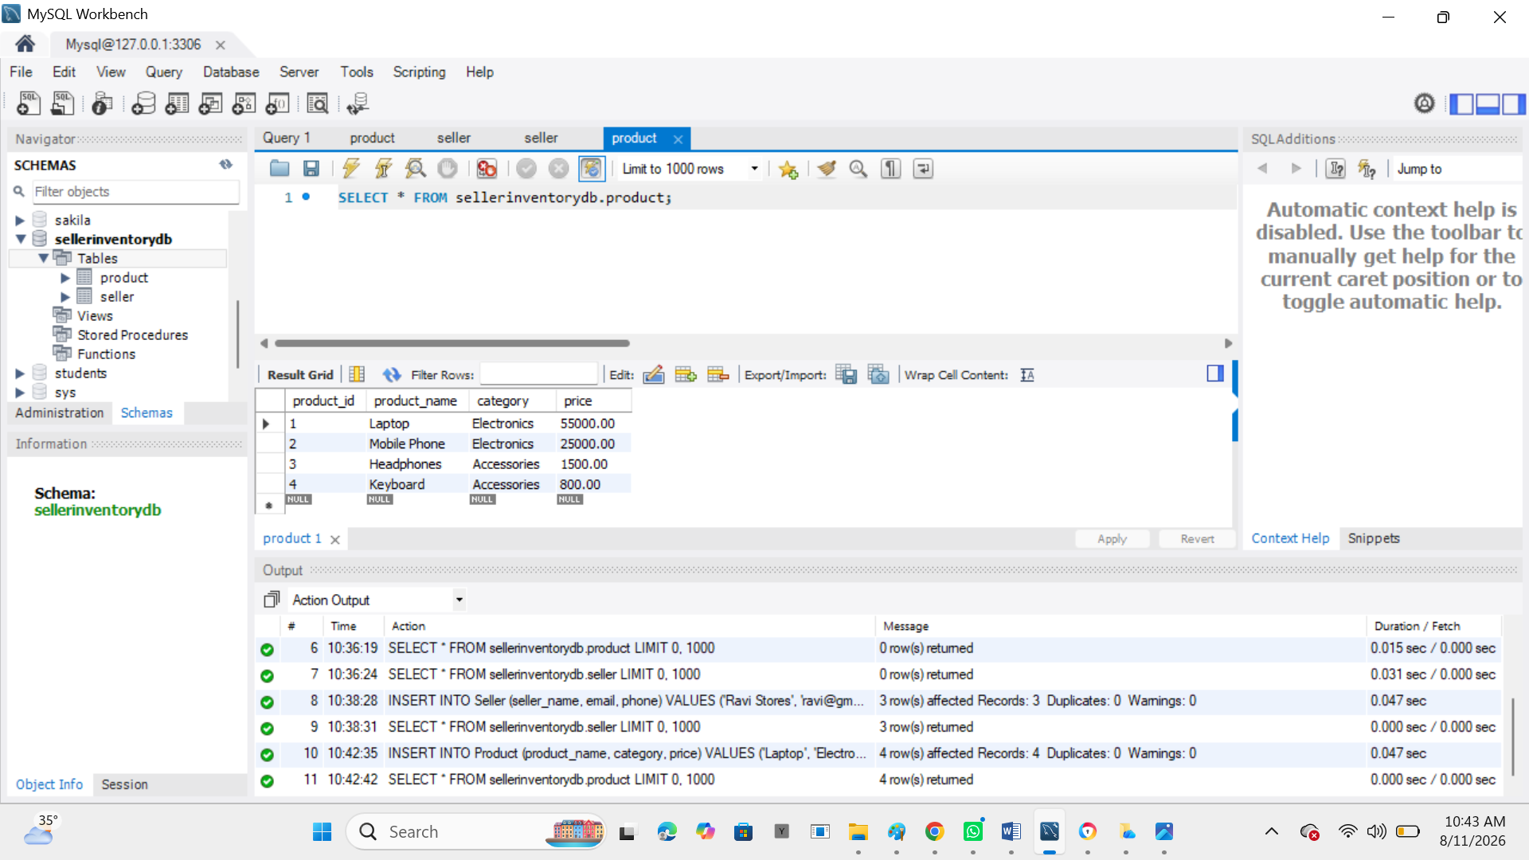

7. Insert Inventory Details
INSERT INTO Inventory (seller_id, product_id, quantity, status)
VALUES
(1, 1, 10, 'Available'),
(1, 3, 0, 'Unavailable'),
(2, 2, 15, 'Available'),
(2, 4, 0, 'Unavailable'),
(3, 1, 5, 'Available');

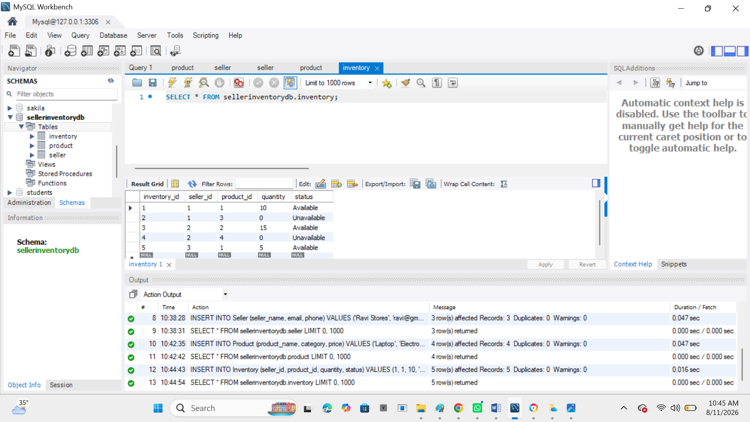

8. Display Seller Product Information
SELECT
s.seller_name,
p.product_name,
p.category,
p.price,
i.quantity,
i.status
FROM Seller s
JOIN Inventory i ON s.seller_id = i.seller_id
JOIN Product p ON i.product_id = p.product_id;

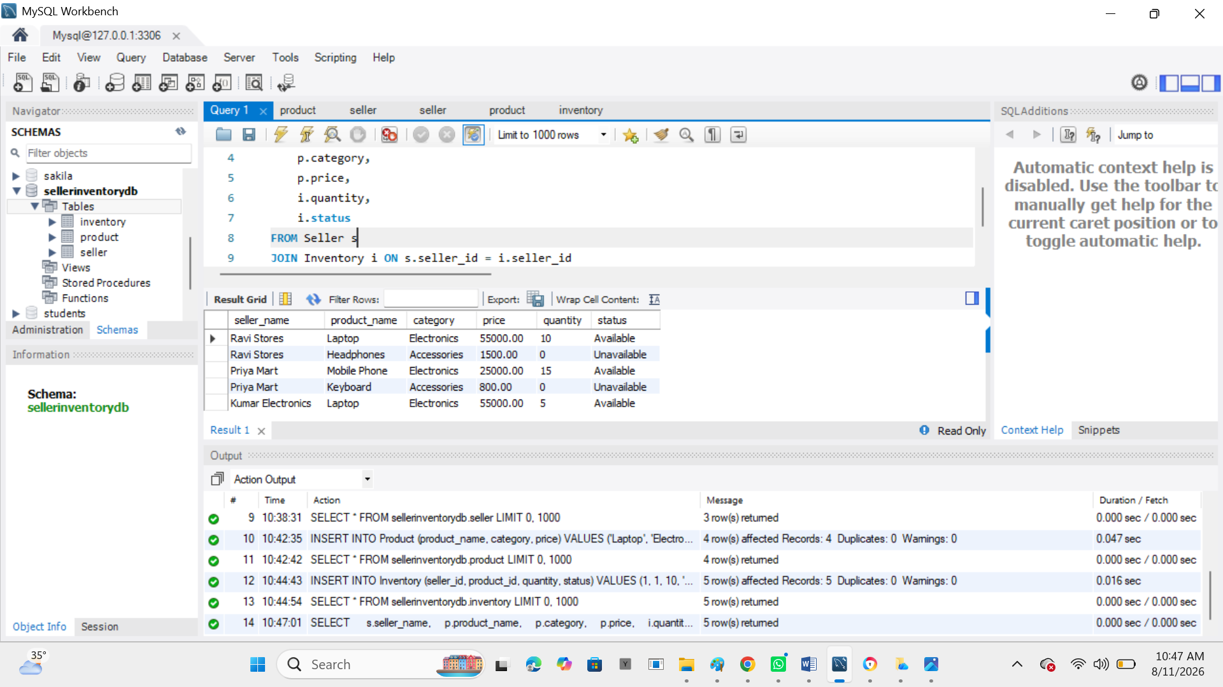

Output
Seller | Product | Category | Price | Quantity | Status
Ravi Stores | Laptop | Electronics | 55000 | 10 | Available
Ravi Stores | Headphones | Accessories | 1500 | 0 | Unavailable
Priya Mart | Mobile Phone | Electronics | 25000 | 15 | Available
Priya Mart | Keyboard | Accessories | 800 | 0 | Unavailable
Kumar Electronics | Laptop | Electronics | 55000 | 5 | Available

9. Find Available Products
SELECT
p.product_name,
s.seller_name,
i.quantity
FROM Inventory i
JOIN Product p ON i.product_id = p.product_id
JOIN Seller s ON i.seller_id = s.seller_id
WHERE i.quantity > 0;

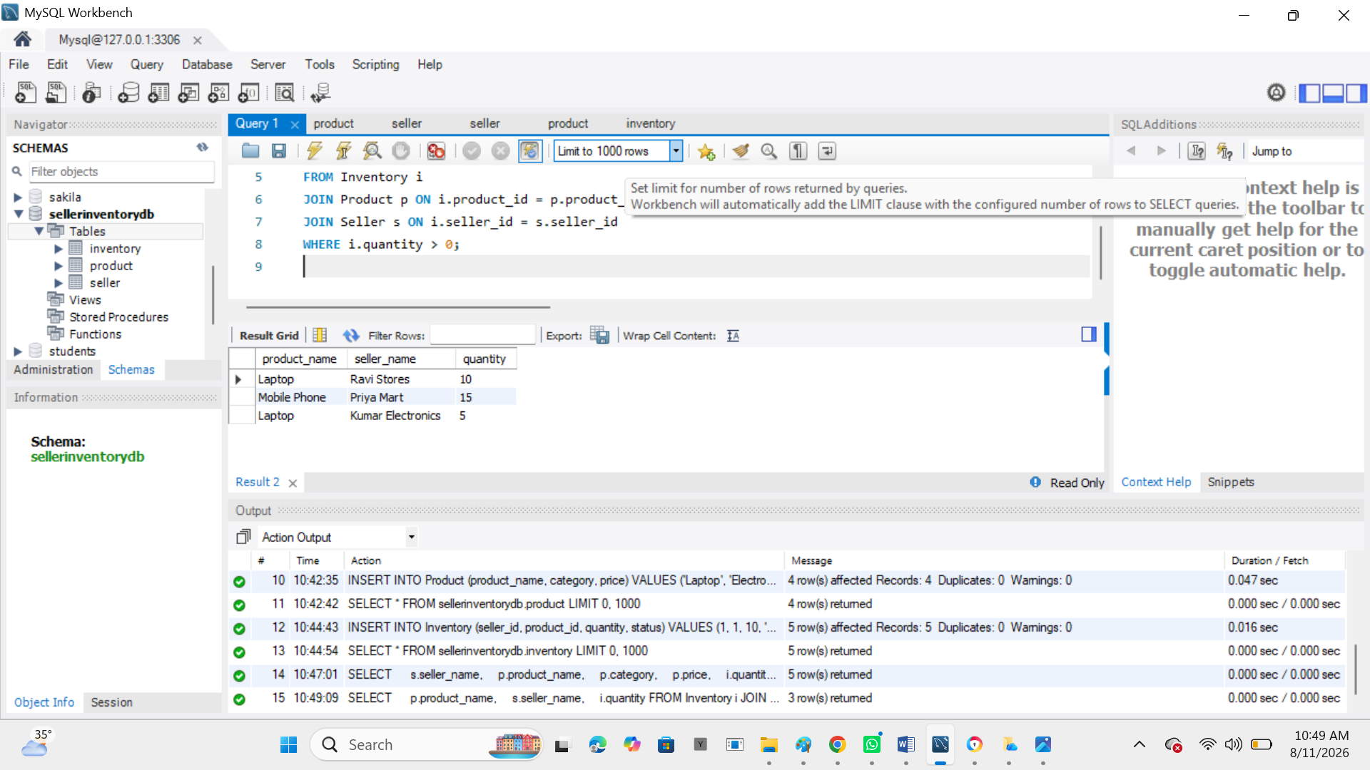

10. Find Unavailable Products
SELECT
p.product_name,
s.seller_name,
i.quantity
FROM Inventory i
JOIN Product p ON i.product_id = p.product_id
JOIN Seller s ON i.seller_id = s.seller_id
WHERE i.quantity = 0;

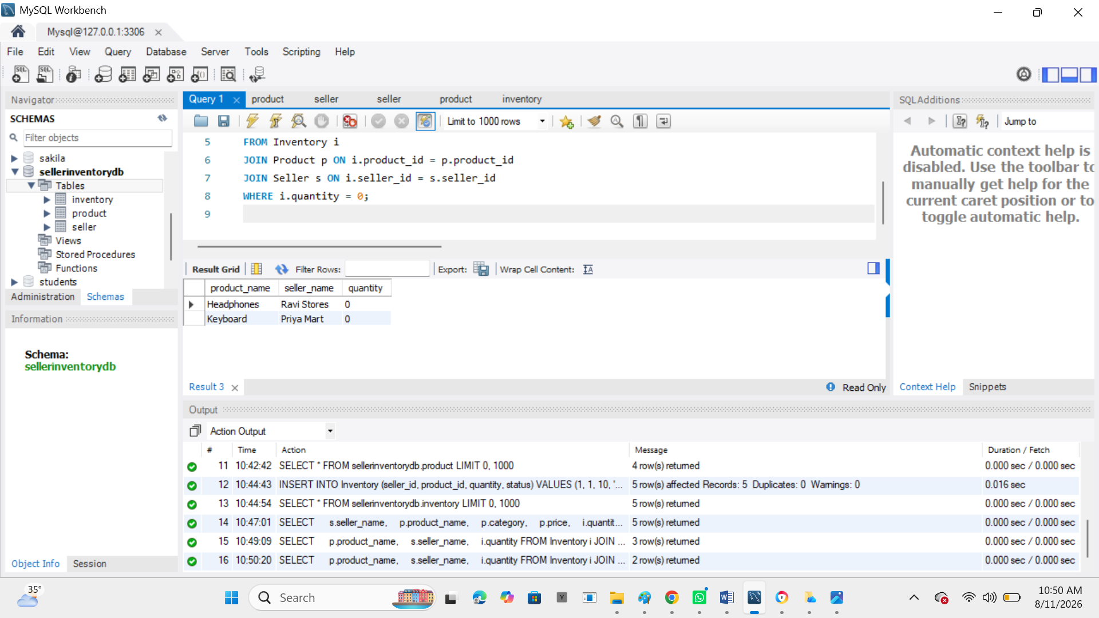

11. Update Inventory
Suppose Ravi Stores receives 20 more laptops:
UPDATE Inventory
SET quantity = quantity + 20,
status = 'Available'
WHERE seller_id = 1
AND product_id = 1;

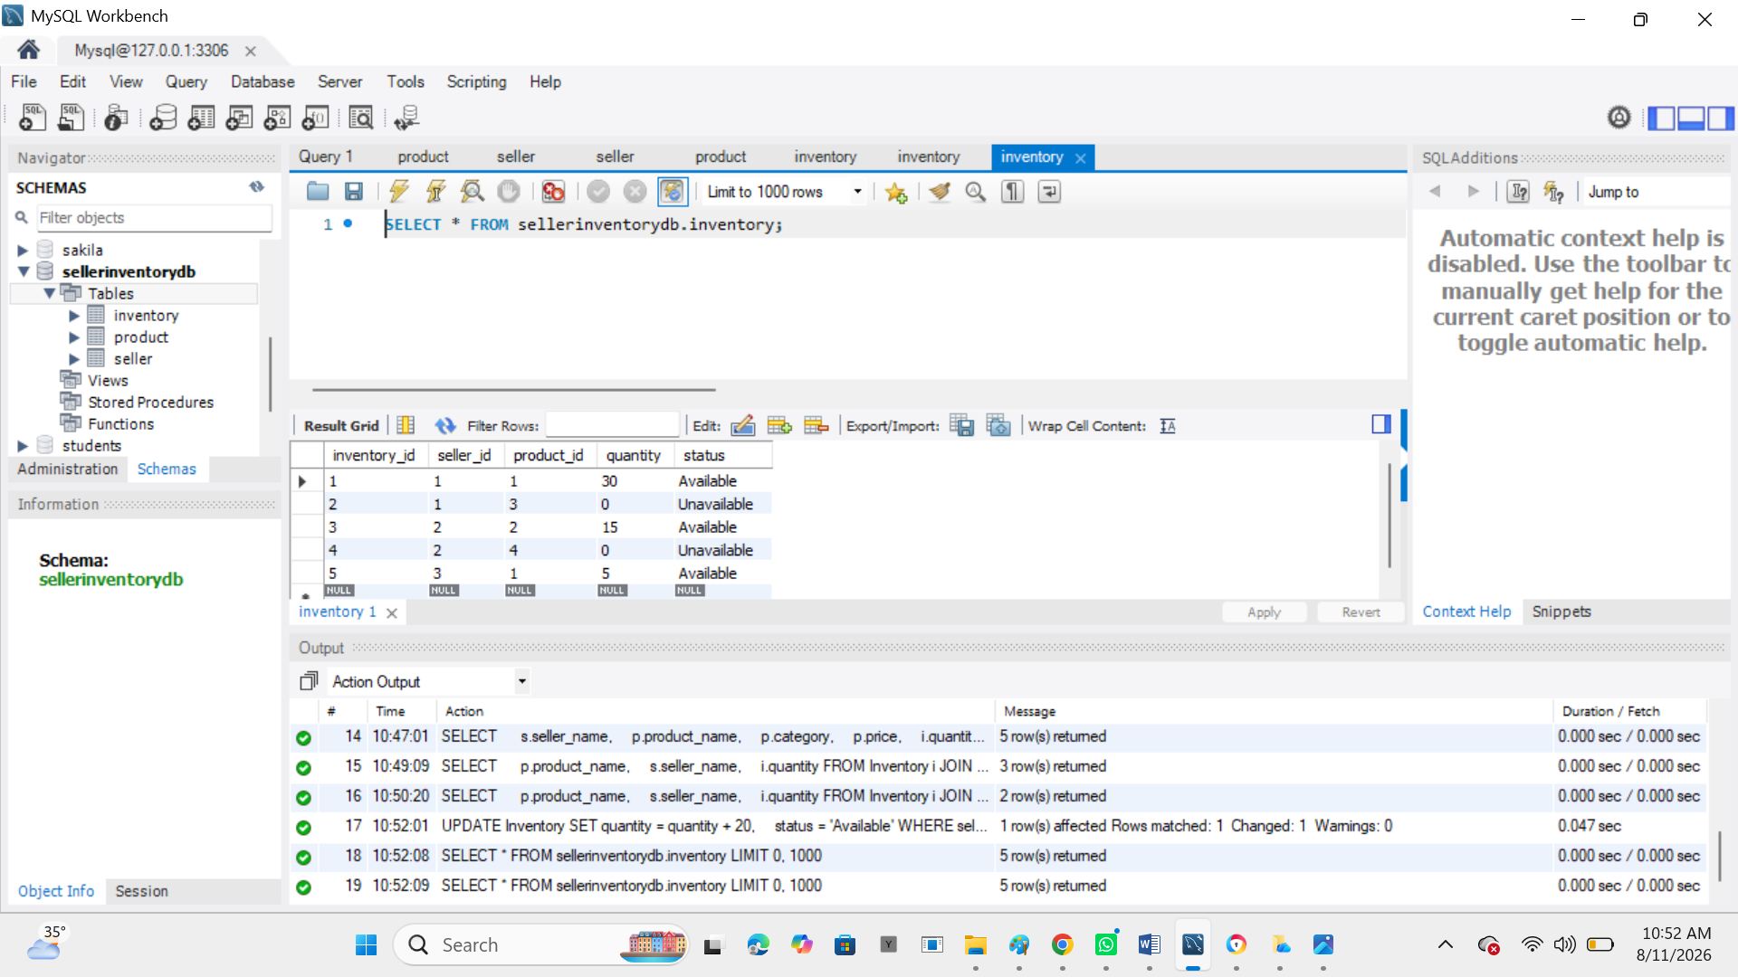

12. Delete Inventory Record
DELETE FROM Inventory
WHERE inventory_id = 2;

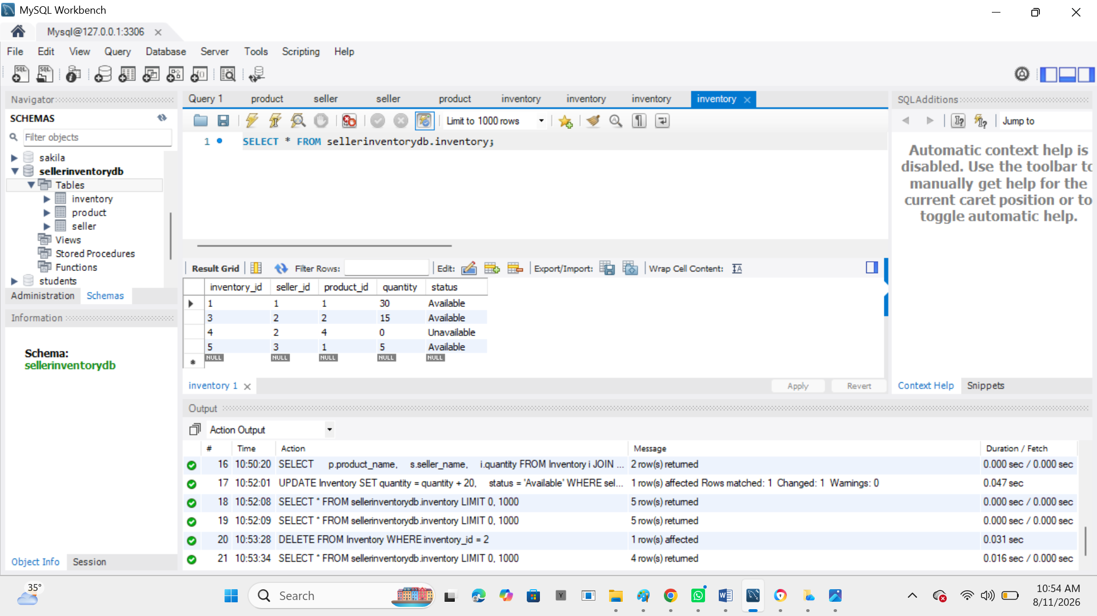

13. Generate Inventory Status Report
SELECT
s.seller_name,
COUNT(i.product_id) AS total_products,
SUM(i.quantity) AS total_quantity,
SUM(CASE WHEN i.quantity > 0 THEN 1 ELSE 0 END) AS available_products,
SUM(CASE WHEN i.quantity = 0 THEN 1 ELSE 0 END) AS unavailable_products
FROM Seller s
LEFT JOIN Inventory i
ON s.seller_id = i.seller_id
GROUP BY s.seller_id, s.seller_name;

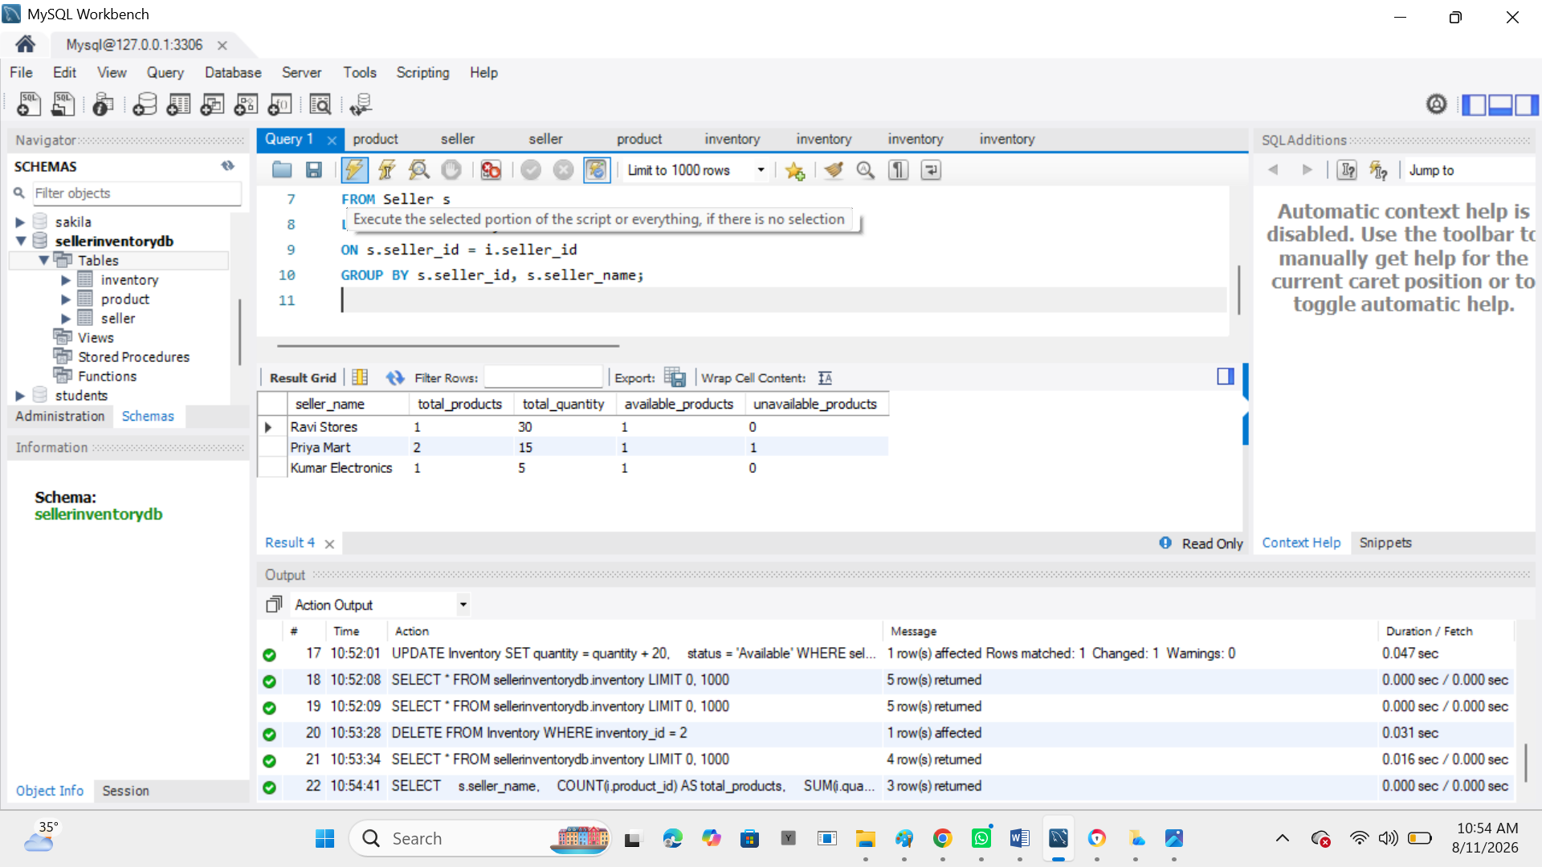

Simple Relationship
SELLER
|
| seller_id
|
v
INVENTORY
|
| product_id
|
v
PRODUCT

